# Create ACR and setting Azure Devops

# Navigate to Container registries page: <https://portal.azure.com/#browse/Microsoft.ContainerRegistry%2Fregistries>

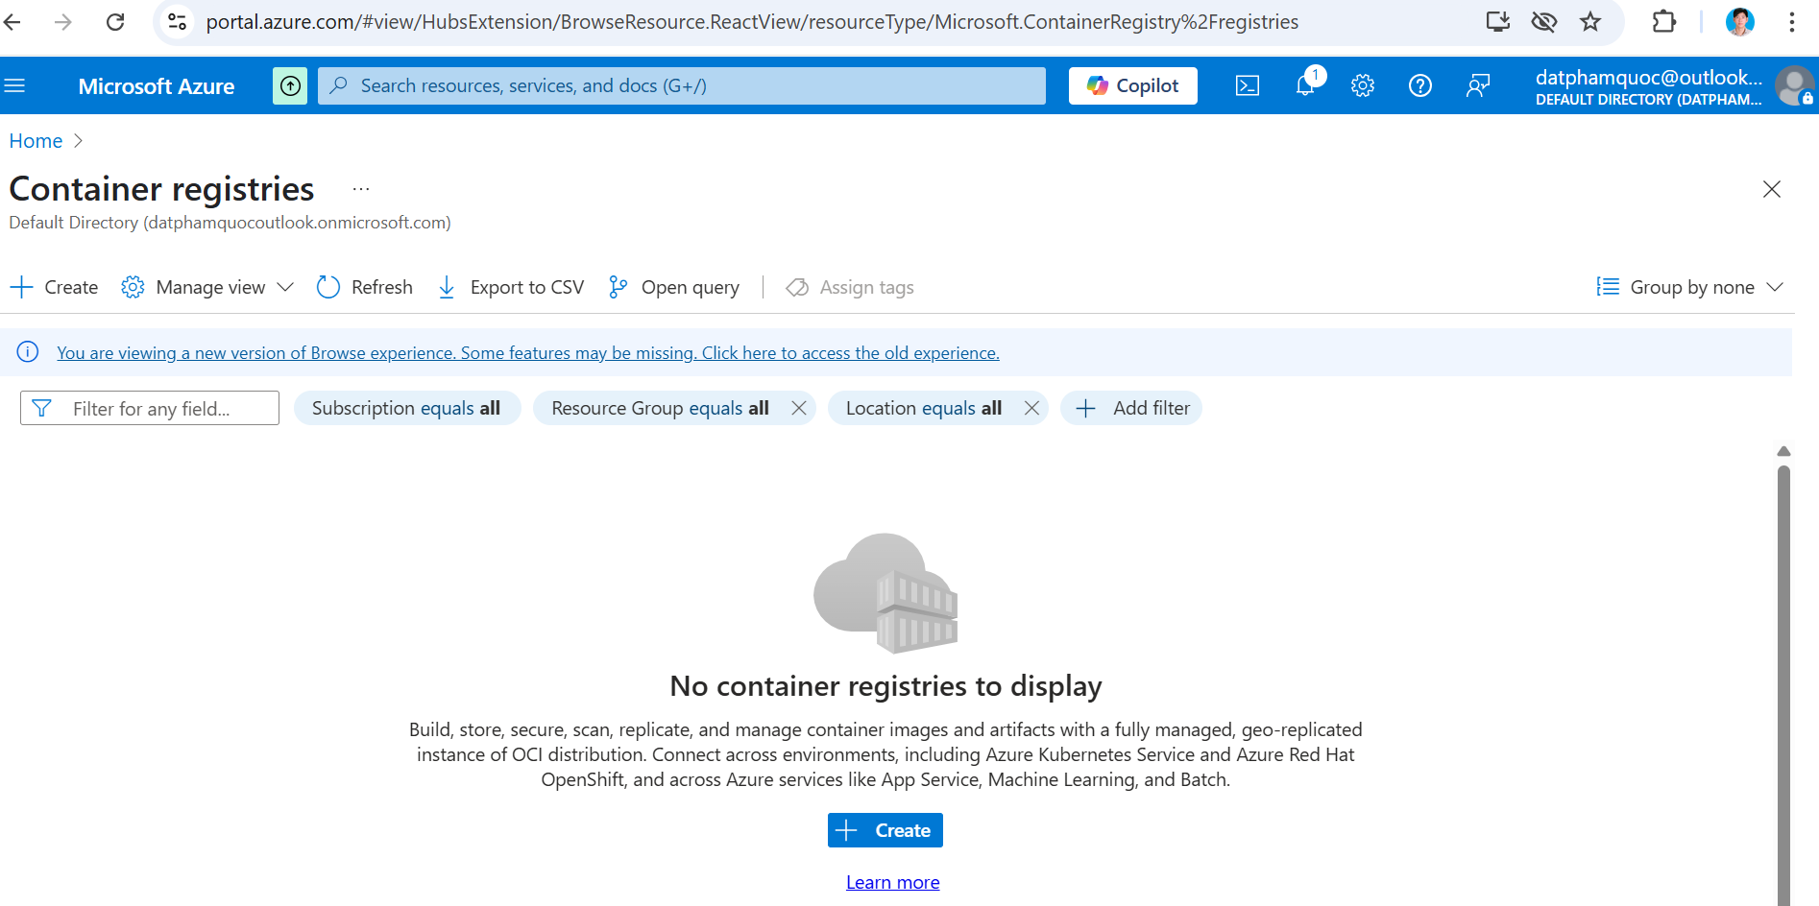

# Click Create button, then put information as below

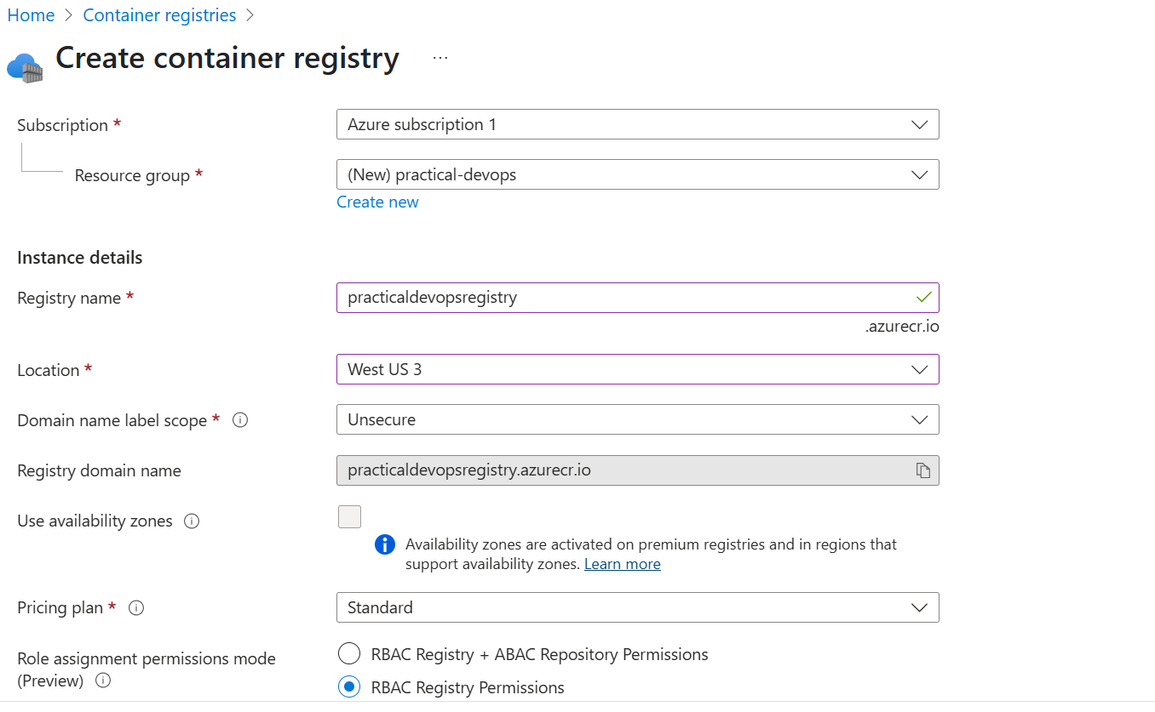

# Click Next: Networking button and keep default

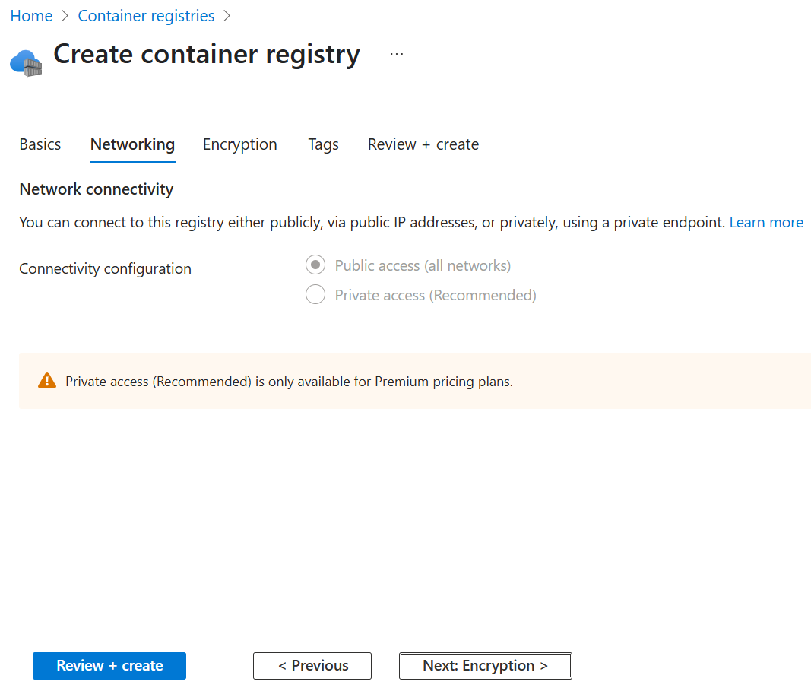

# Click Next: Encryption button and keep default

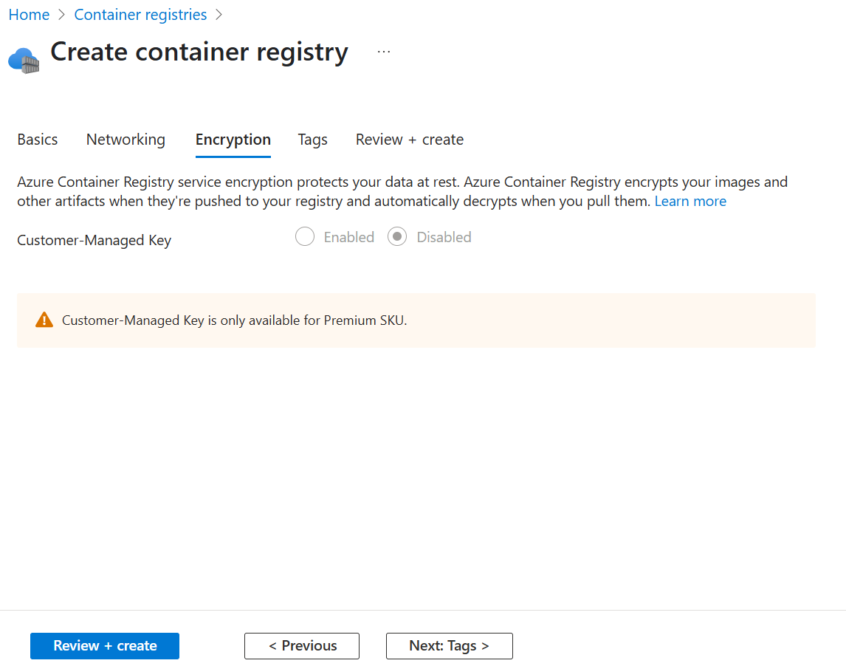

# Click Review + create button

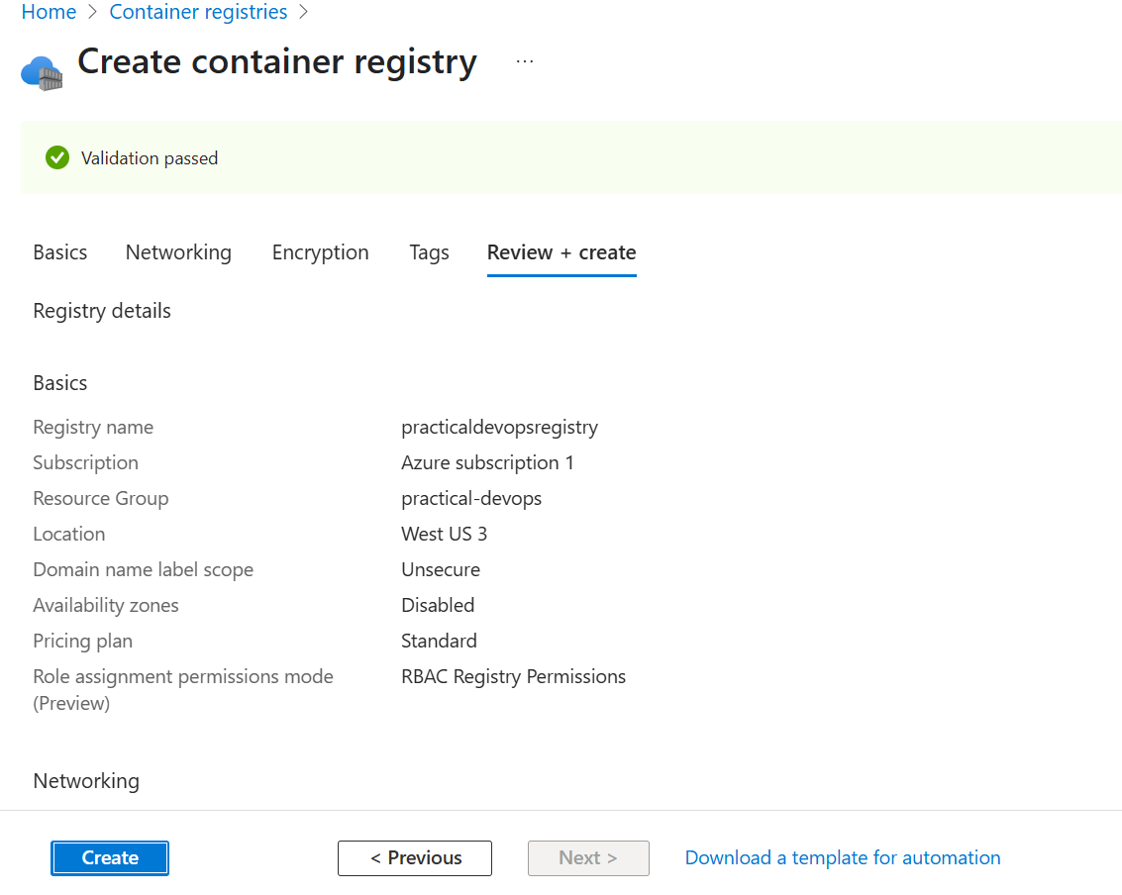

# Click Create, new registry is created

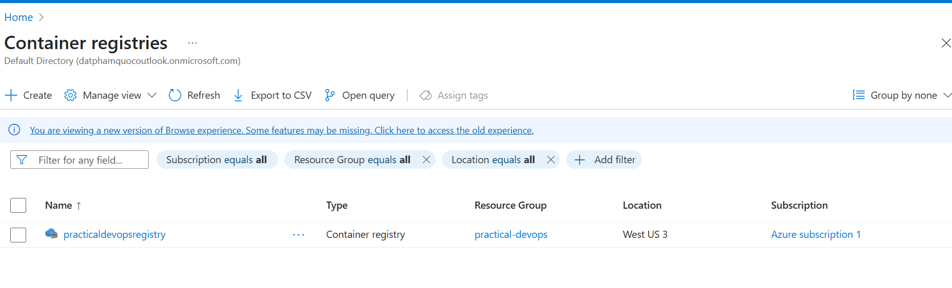

**Login to ECR**

docker login practicaldevopsregistry.azurecr.io

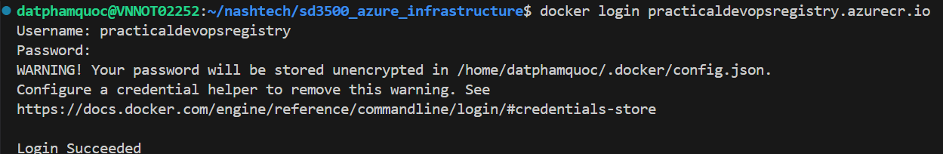

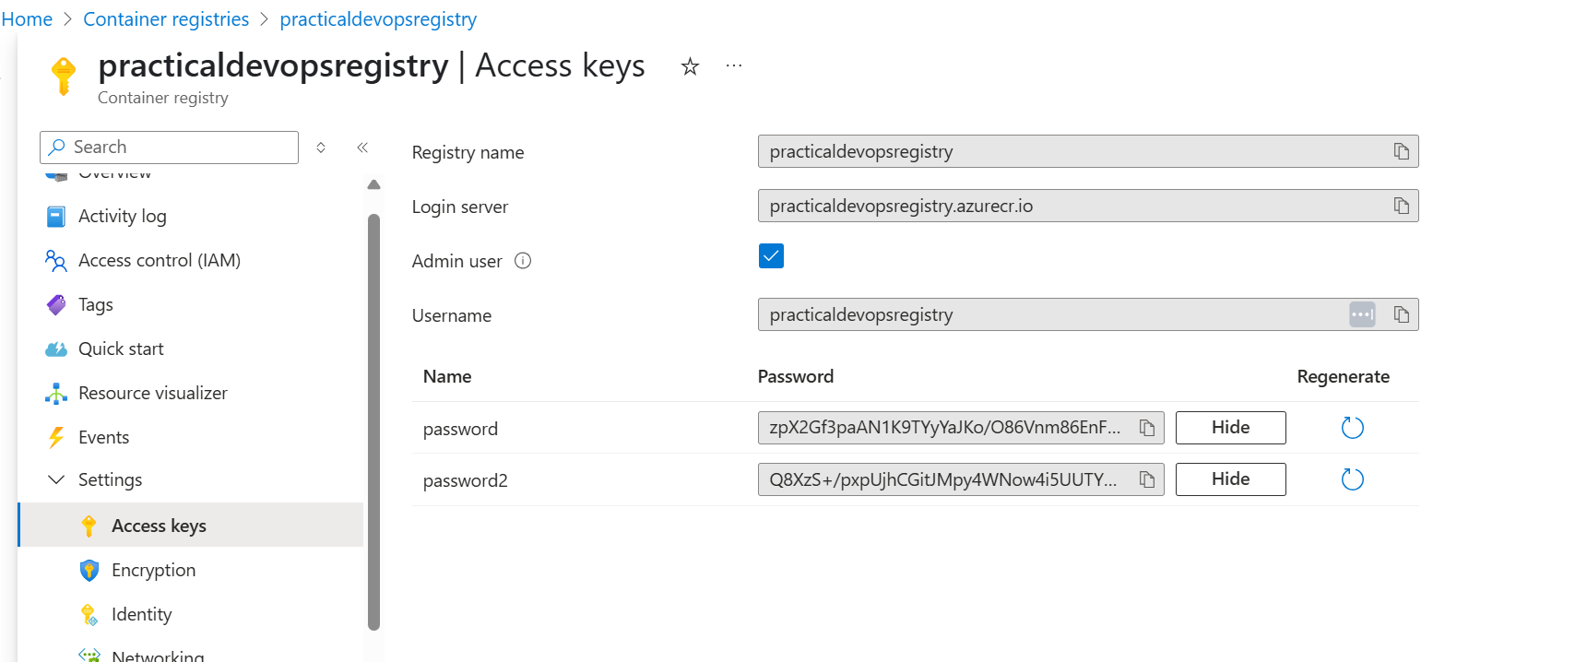

# Configure Azure Devops

**Integrate with Sonarcloud**

# Create project in sonarcloud

After create account from Github, you can create project for existing repository in your Github.

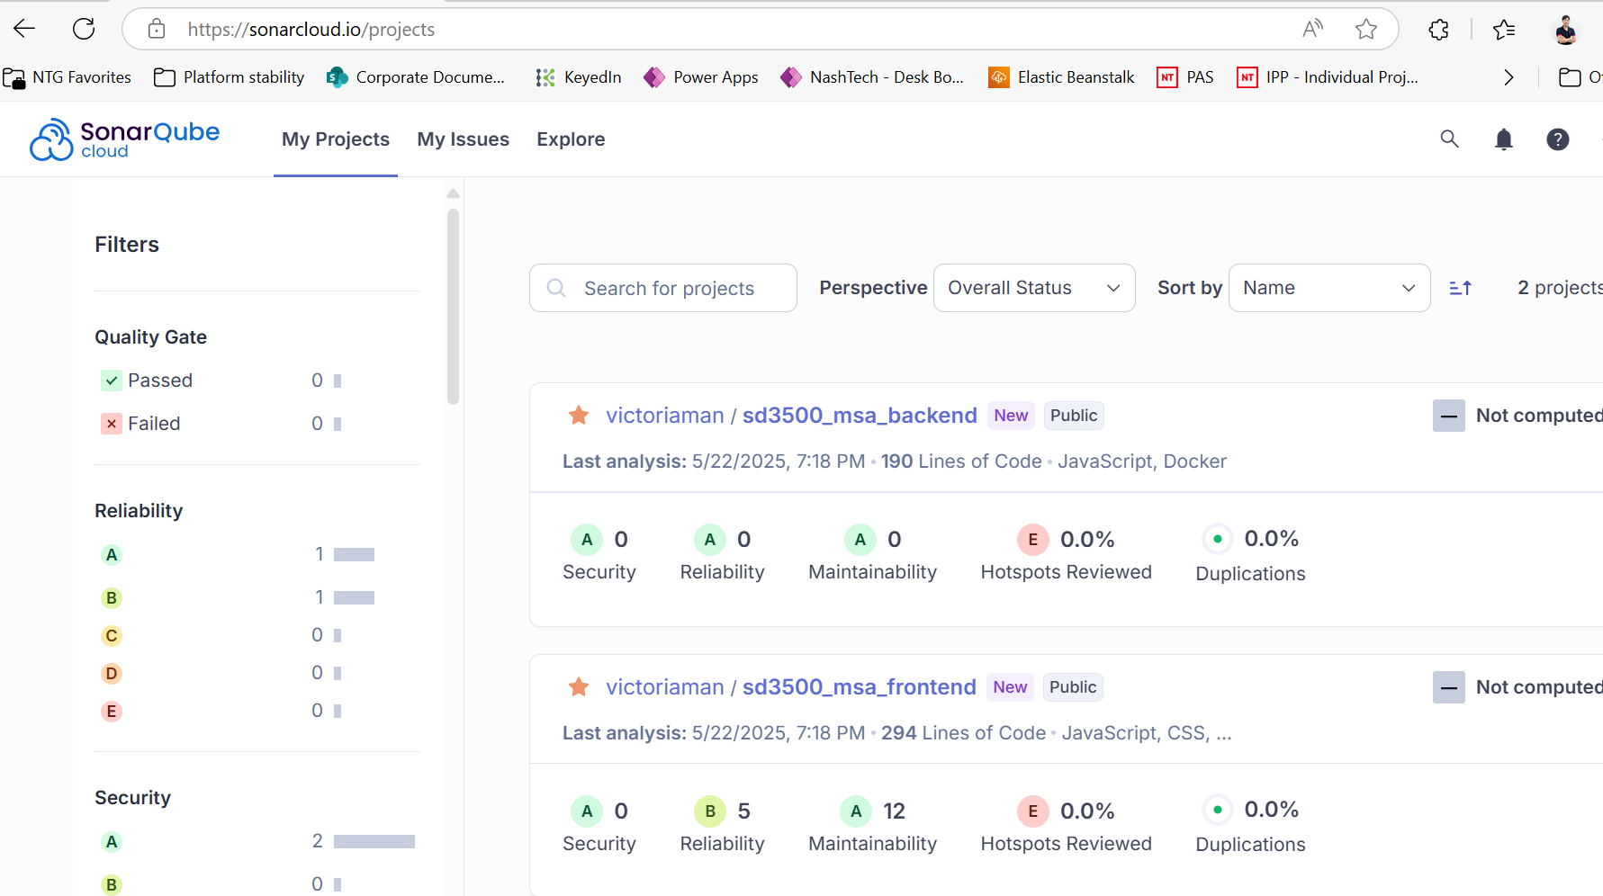

# To integrate Azure Devops with sonarcloud, you need to get project key of specific project in sonarcloud, Organization Key and Access Token

# Choose sd3500_msa_frontend project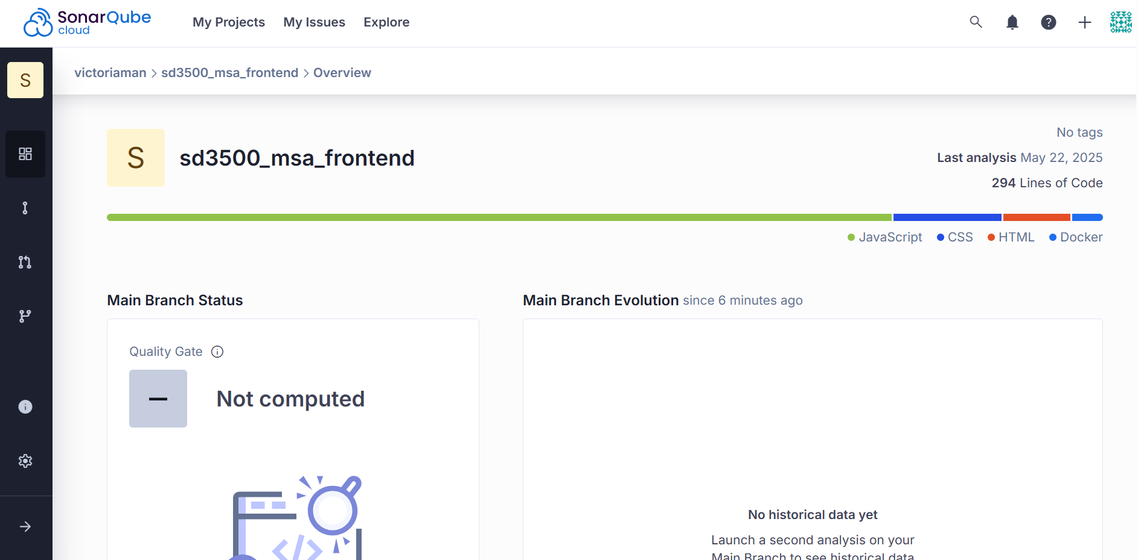

# Click Information menu

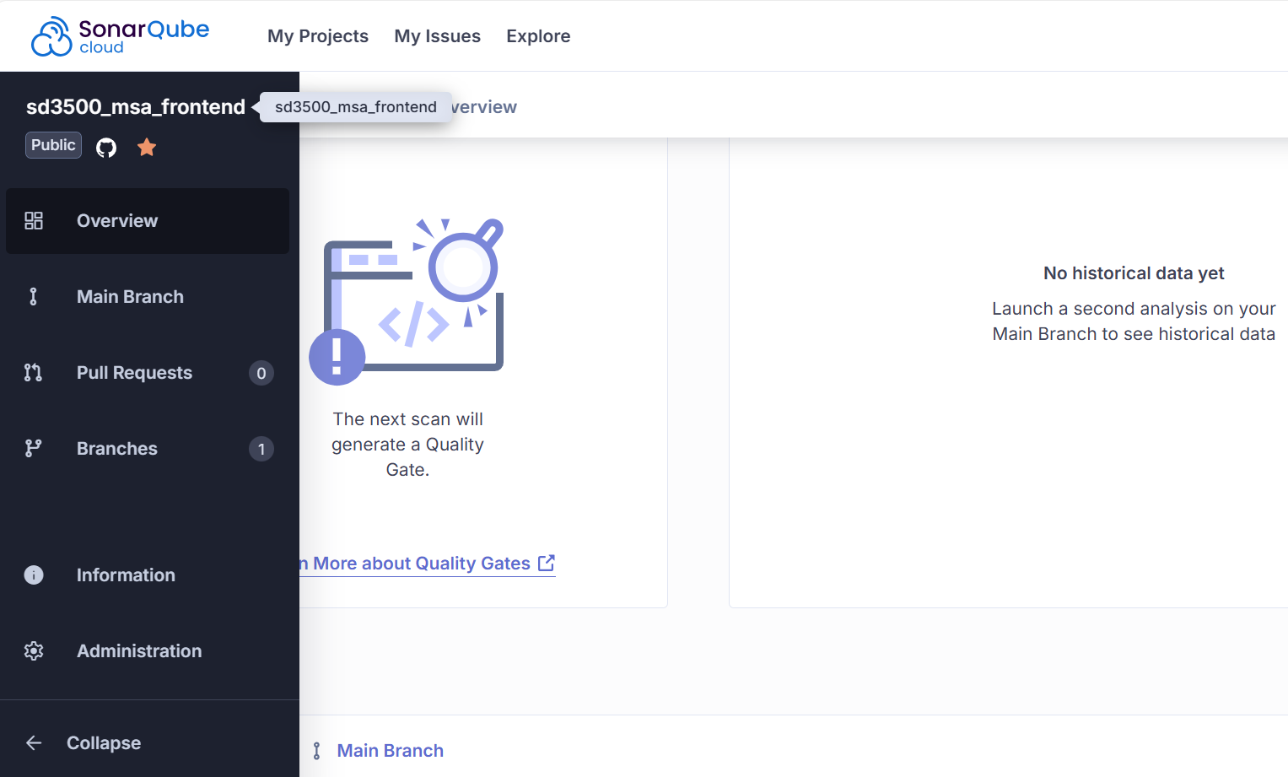

# You can see Project Key and Organization Key

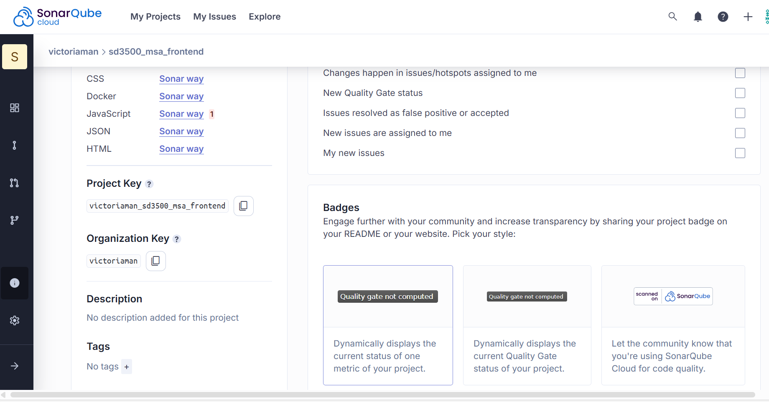

Click My Account

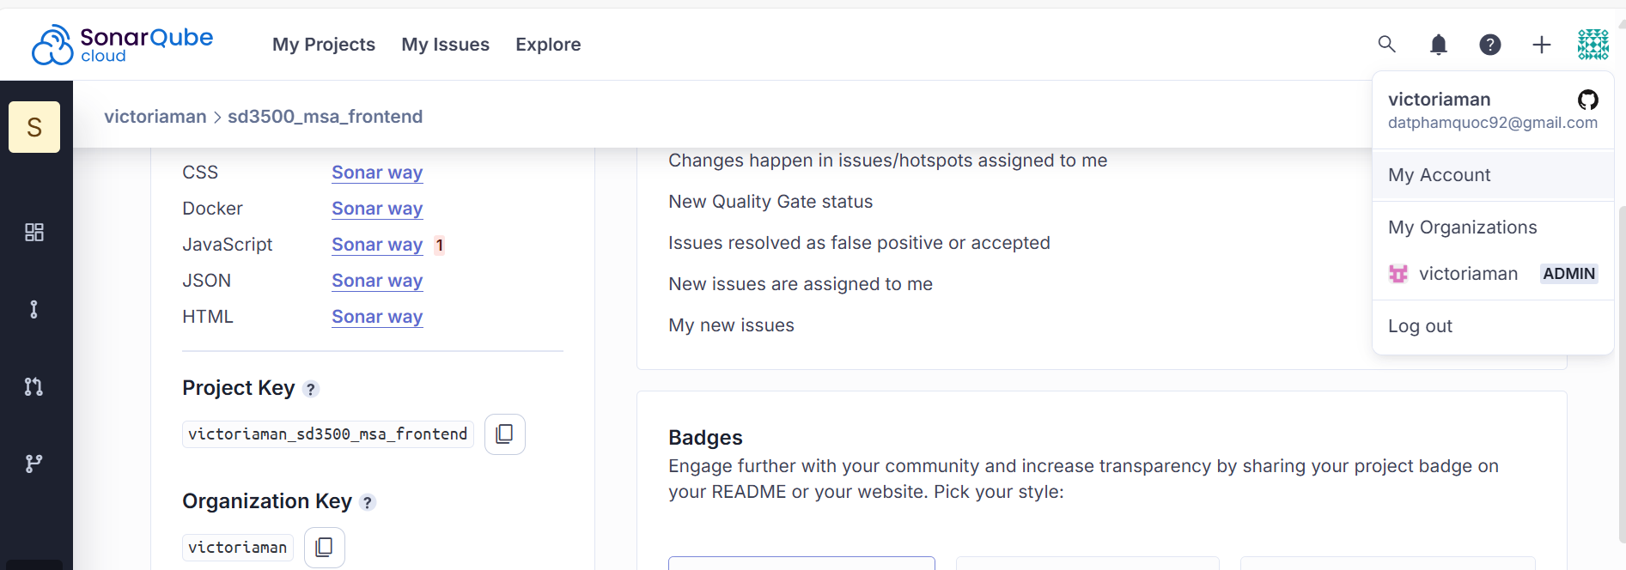

# Click Security tab

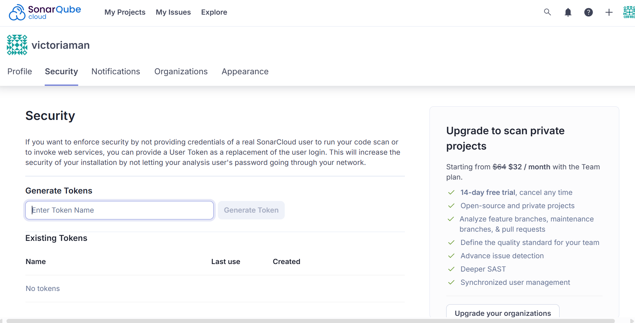

# Enter token name then click Generate Token

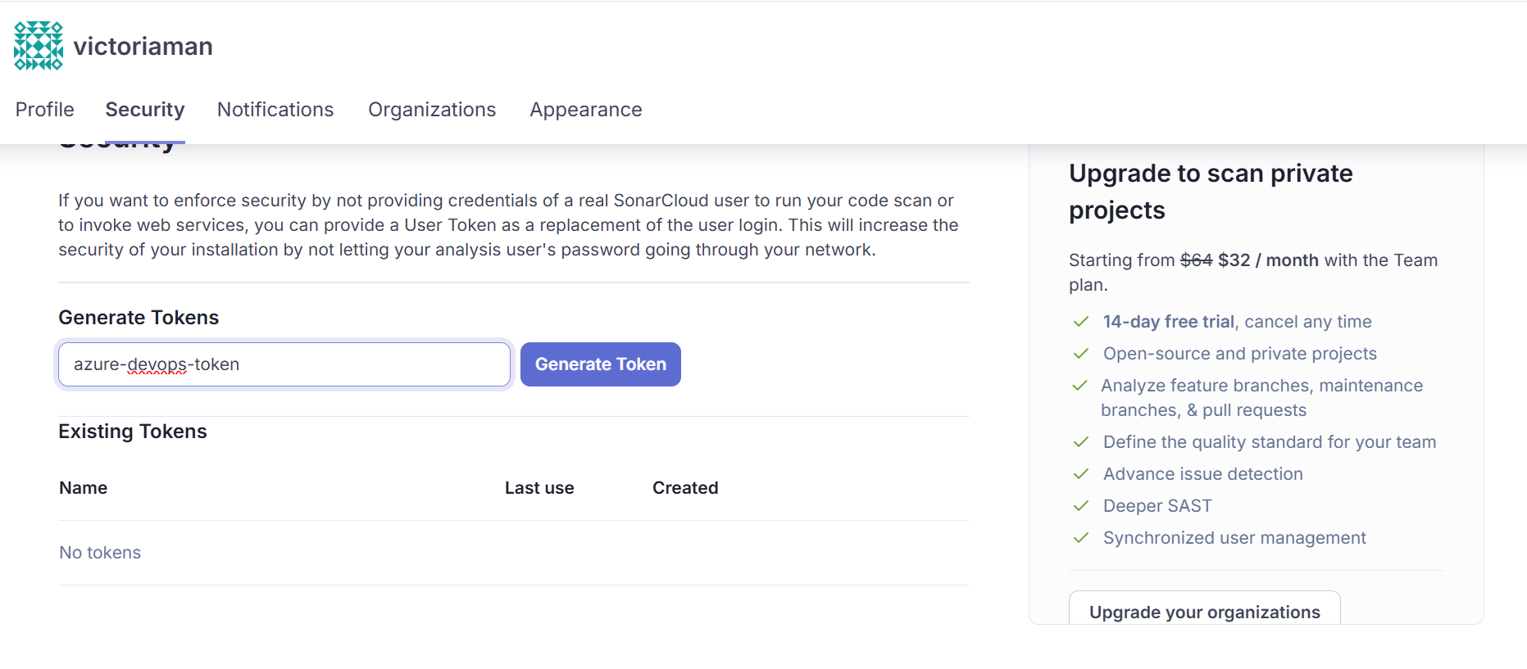

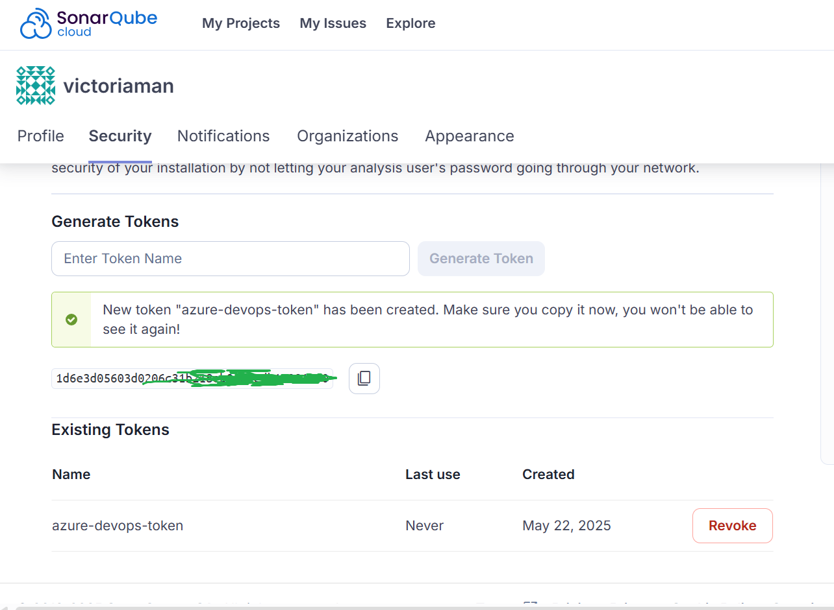

# Navigate to Azure devops page <https://dev.azure.com/datphamquoc/>

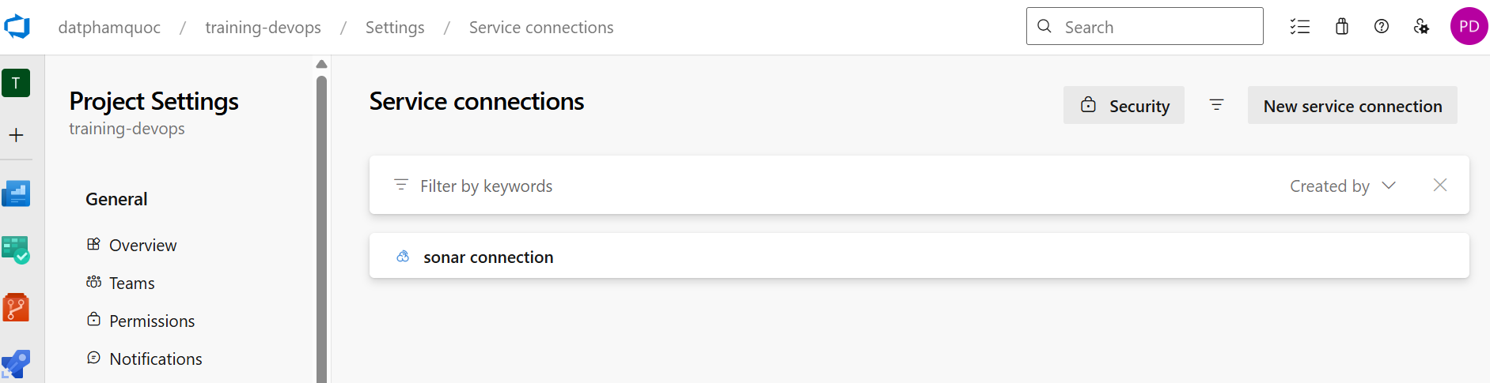

**Create project in Azure devops**

# Navigate to home page

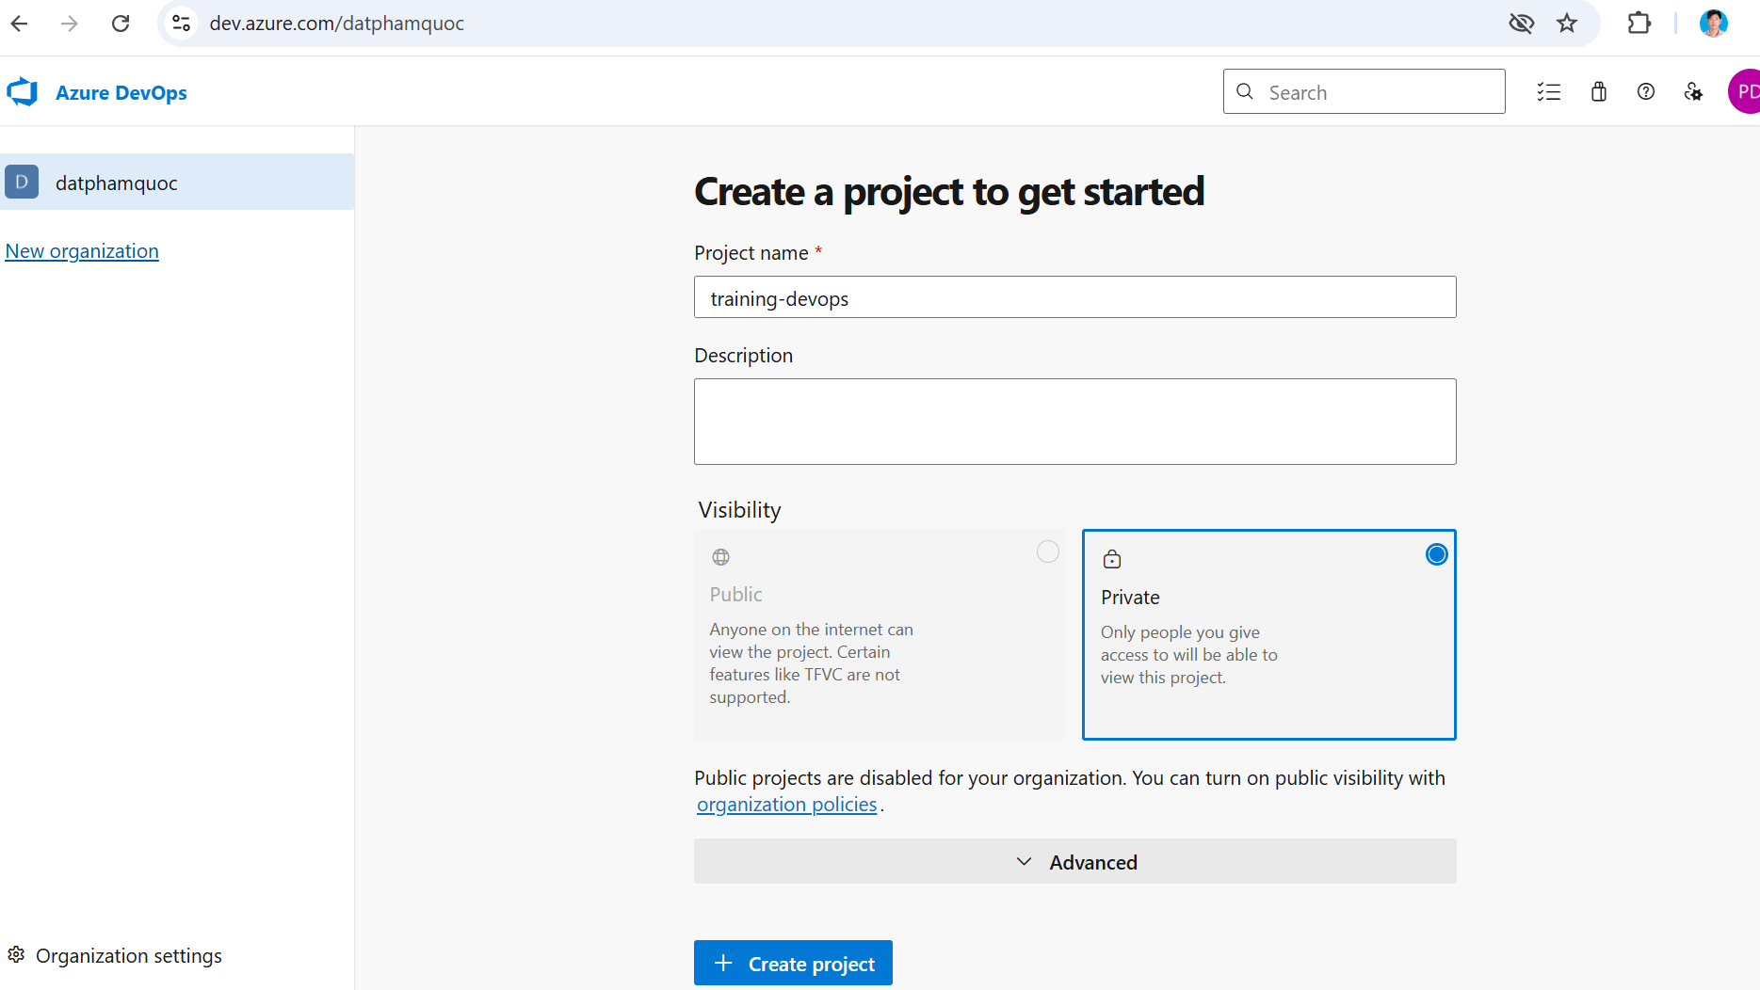

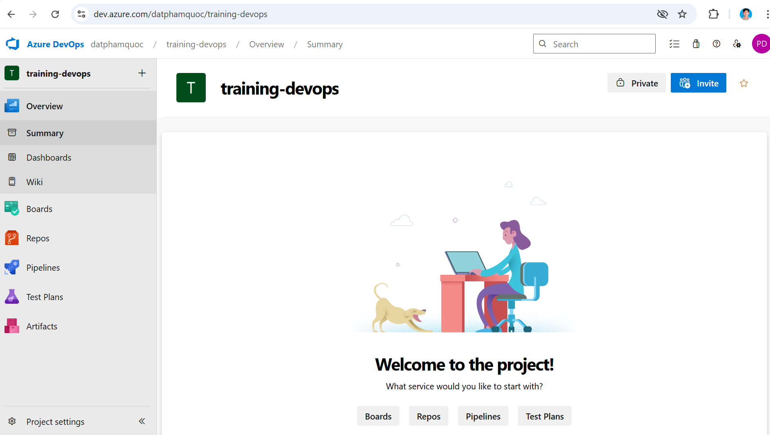

**Create Sonar cloud service connection**

# In the training-devops project, click Project settings menu

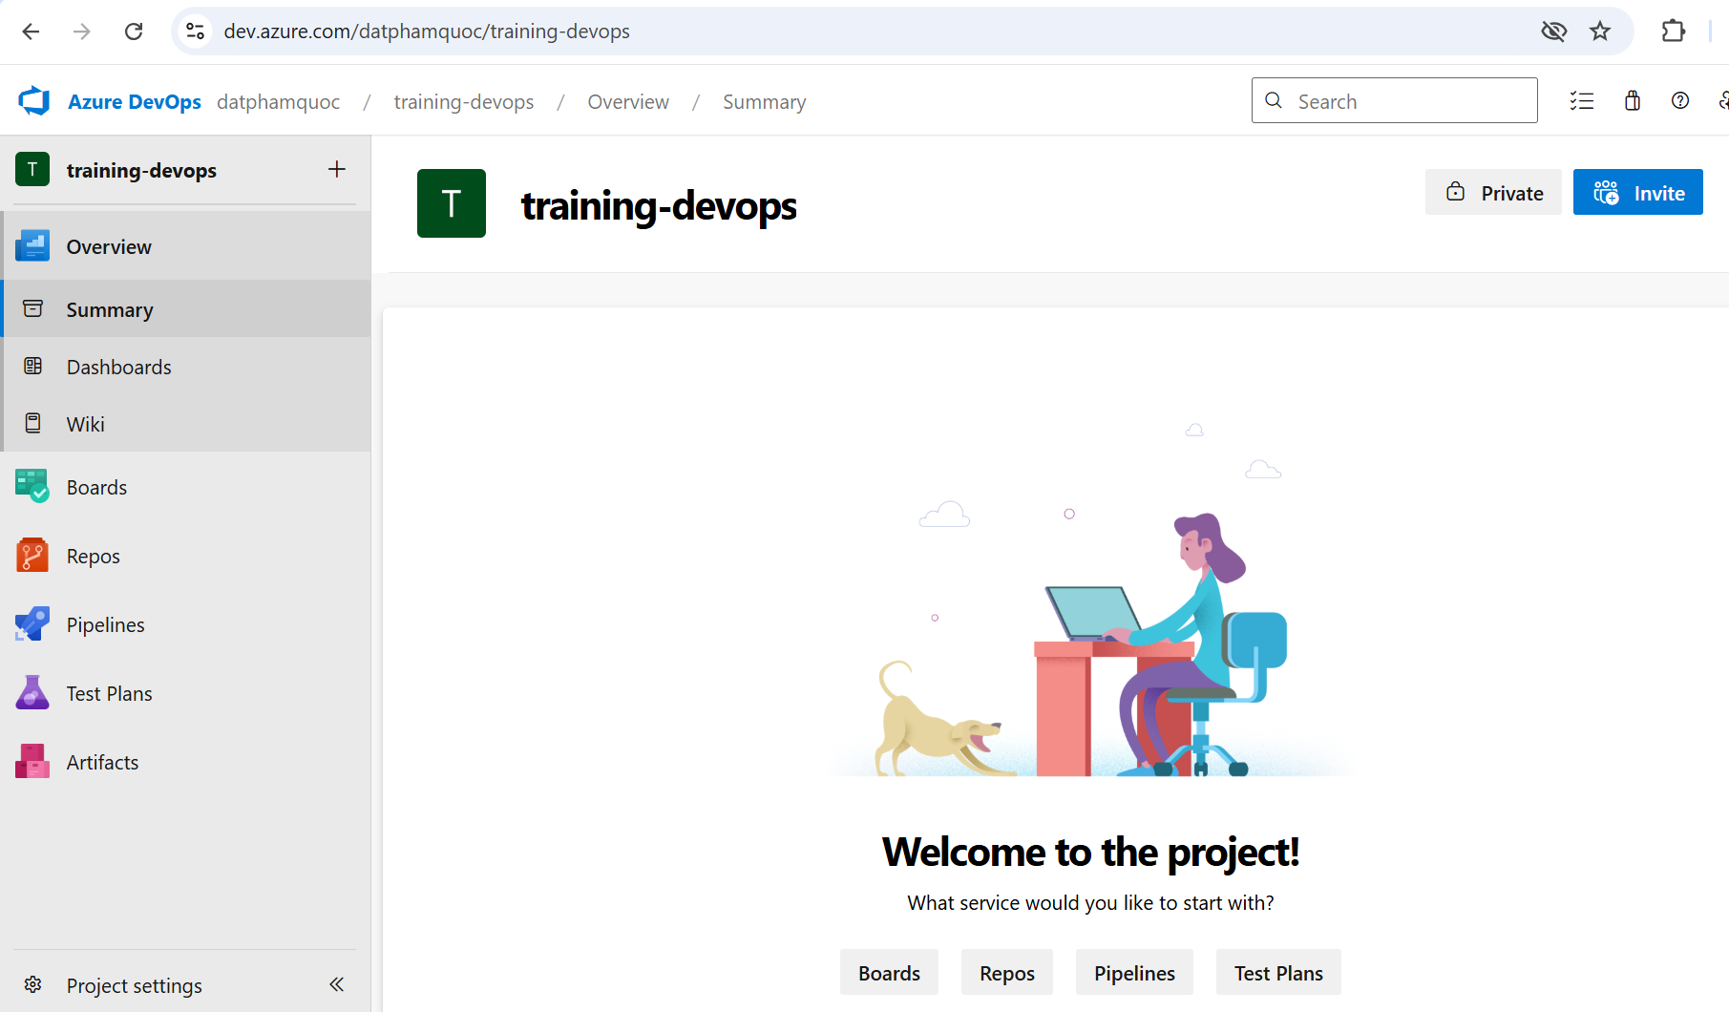

# Click Service connections menu

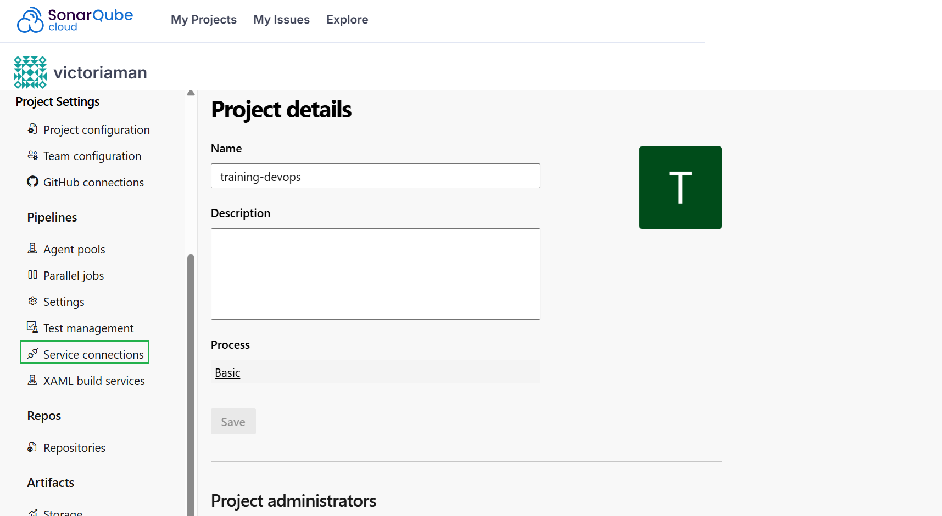

Click Create service connection

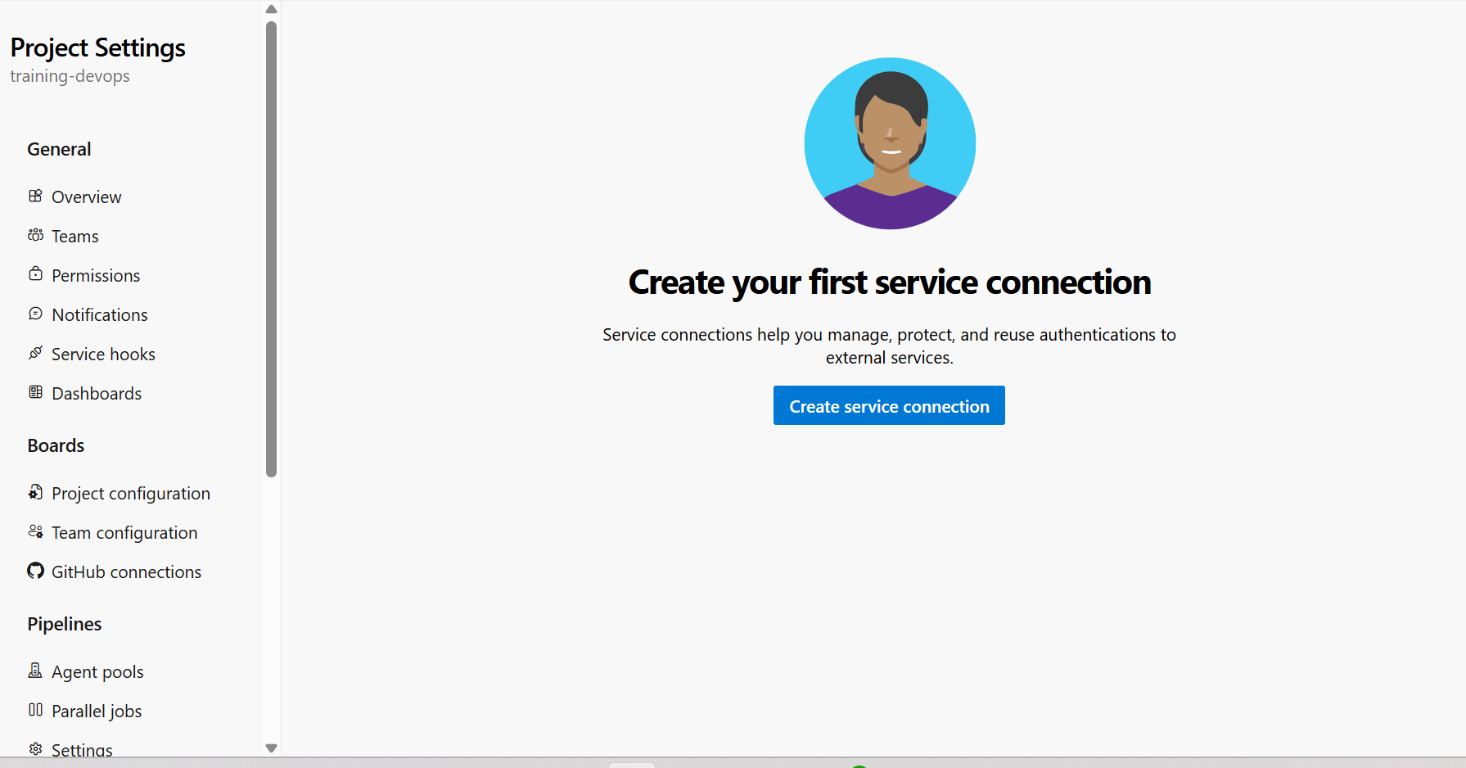

Note: Before create service connect to Sonar cloud, you **must install the SonarQube or SonarCloud extension** into Azure DevOps first

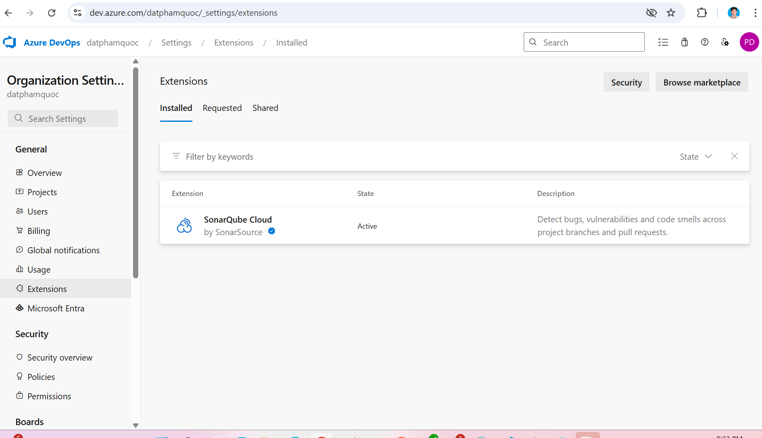

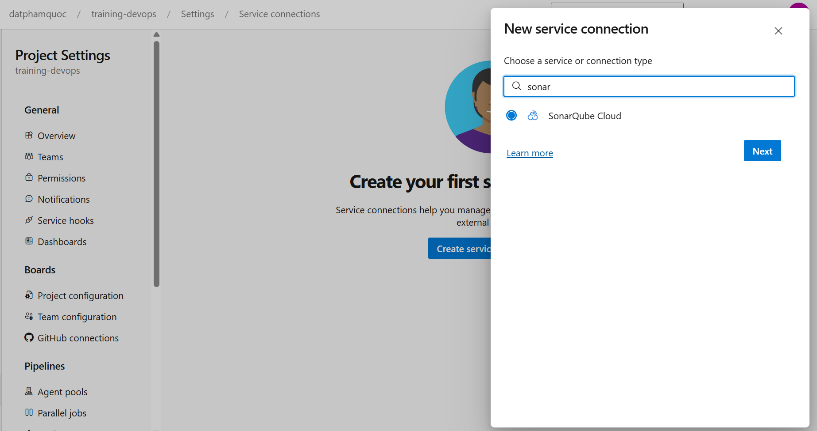

# Paste Sonar cloud token that is gotten from previous step then click Verify for verifying

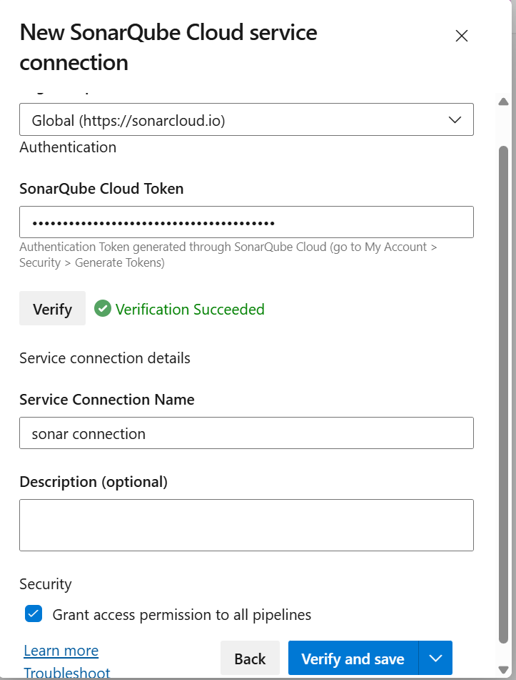

New connection is created

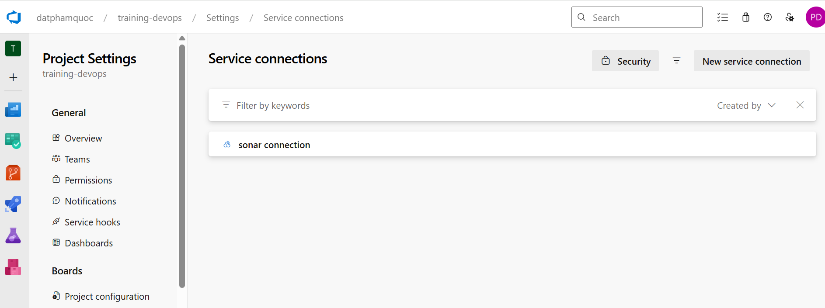

**Create Environment (This step only required when deploy app to AKS)**

Go to Azure DevOps > Pipelines > Environments, click Create environment

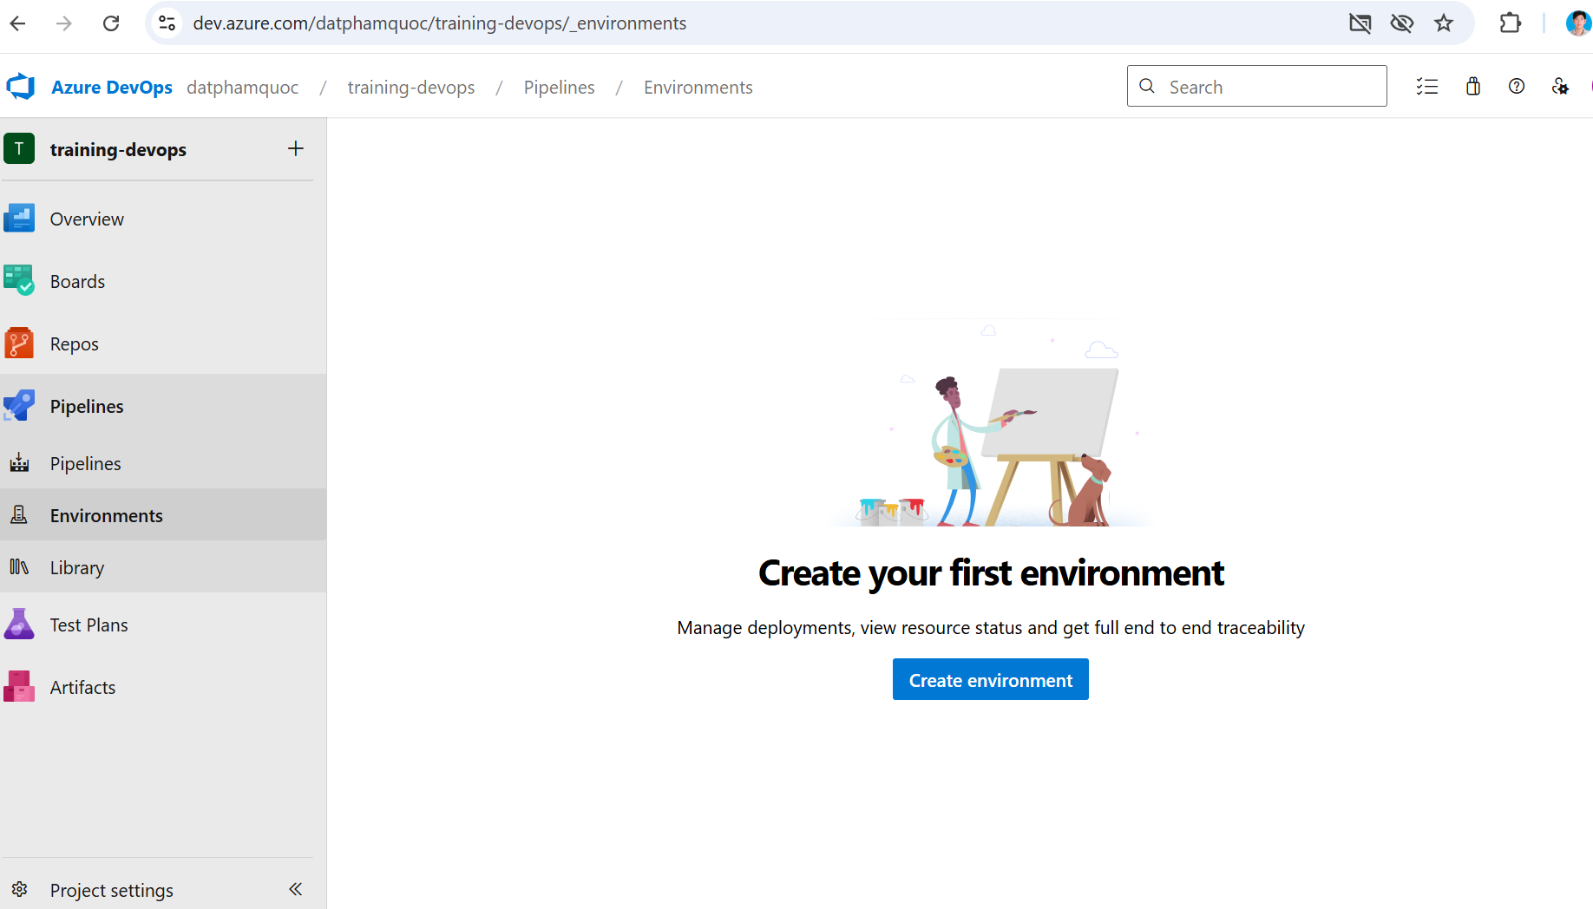

Input information as below, click Next

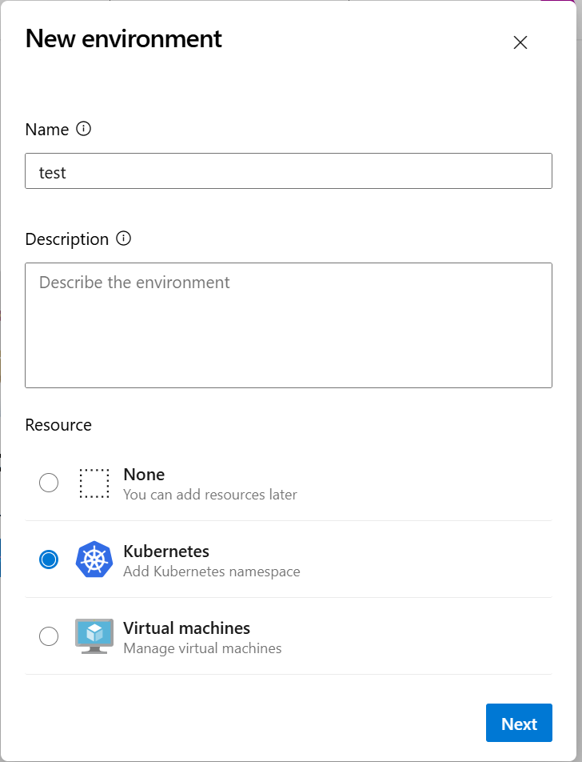

Choose information as below, click Validate and create

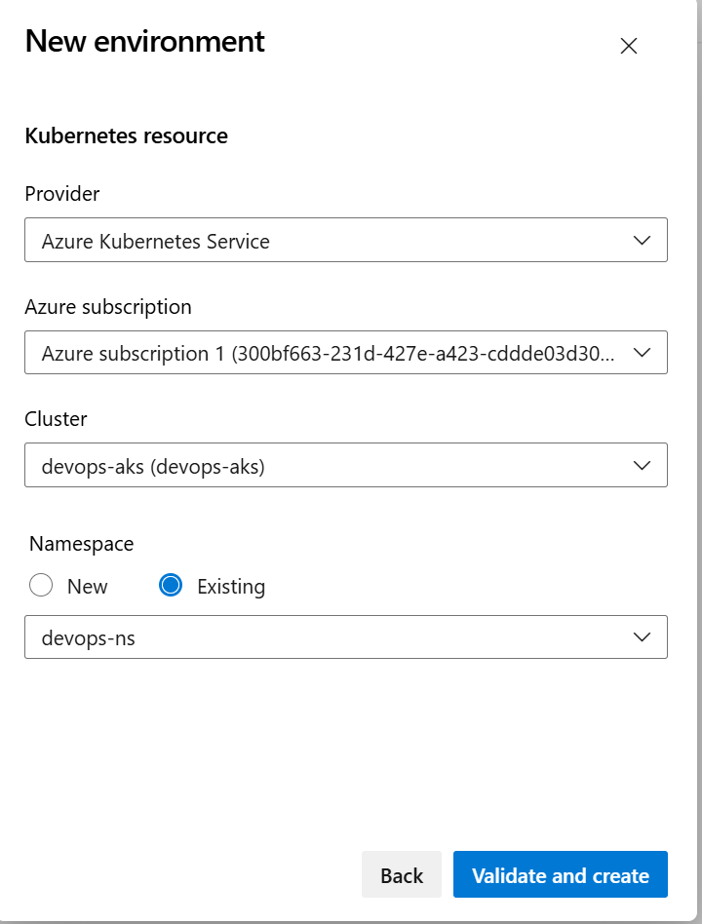

Test environment is created

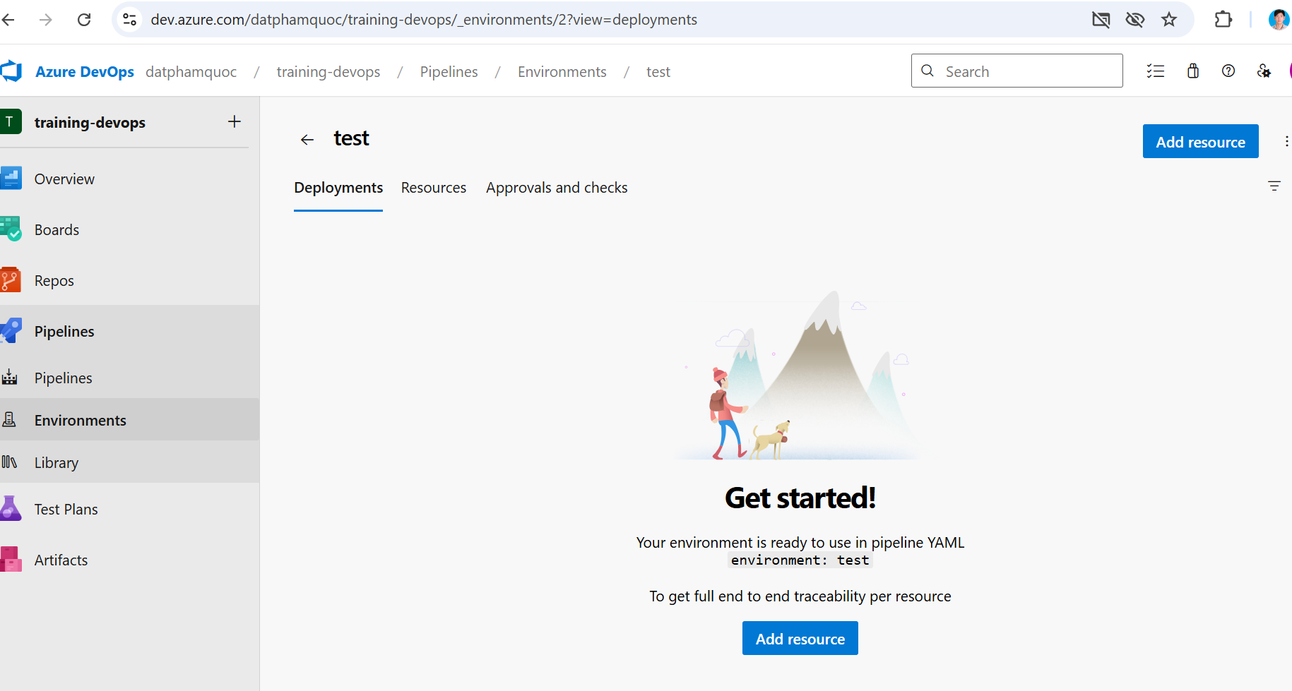

**Create Azure service connection (used for AzureCLI@2 task in pipeline)**

Choose Azure Resource Manager => Next

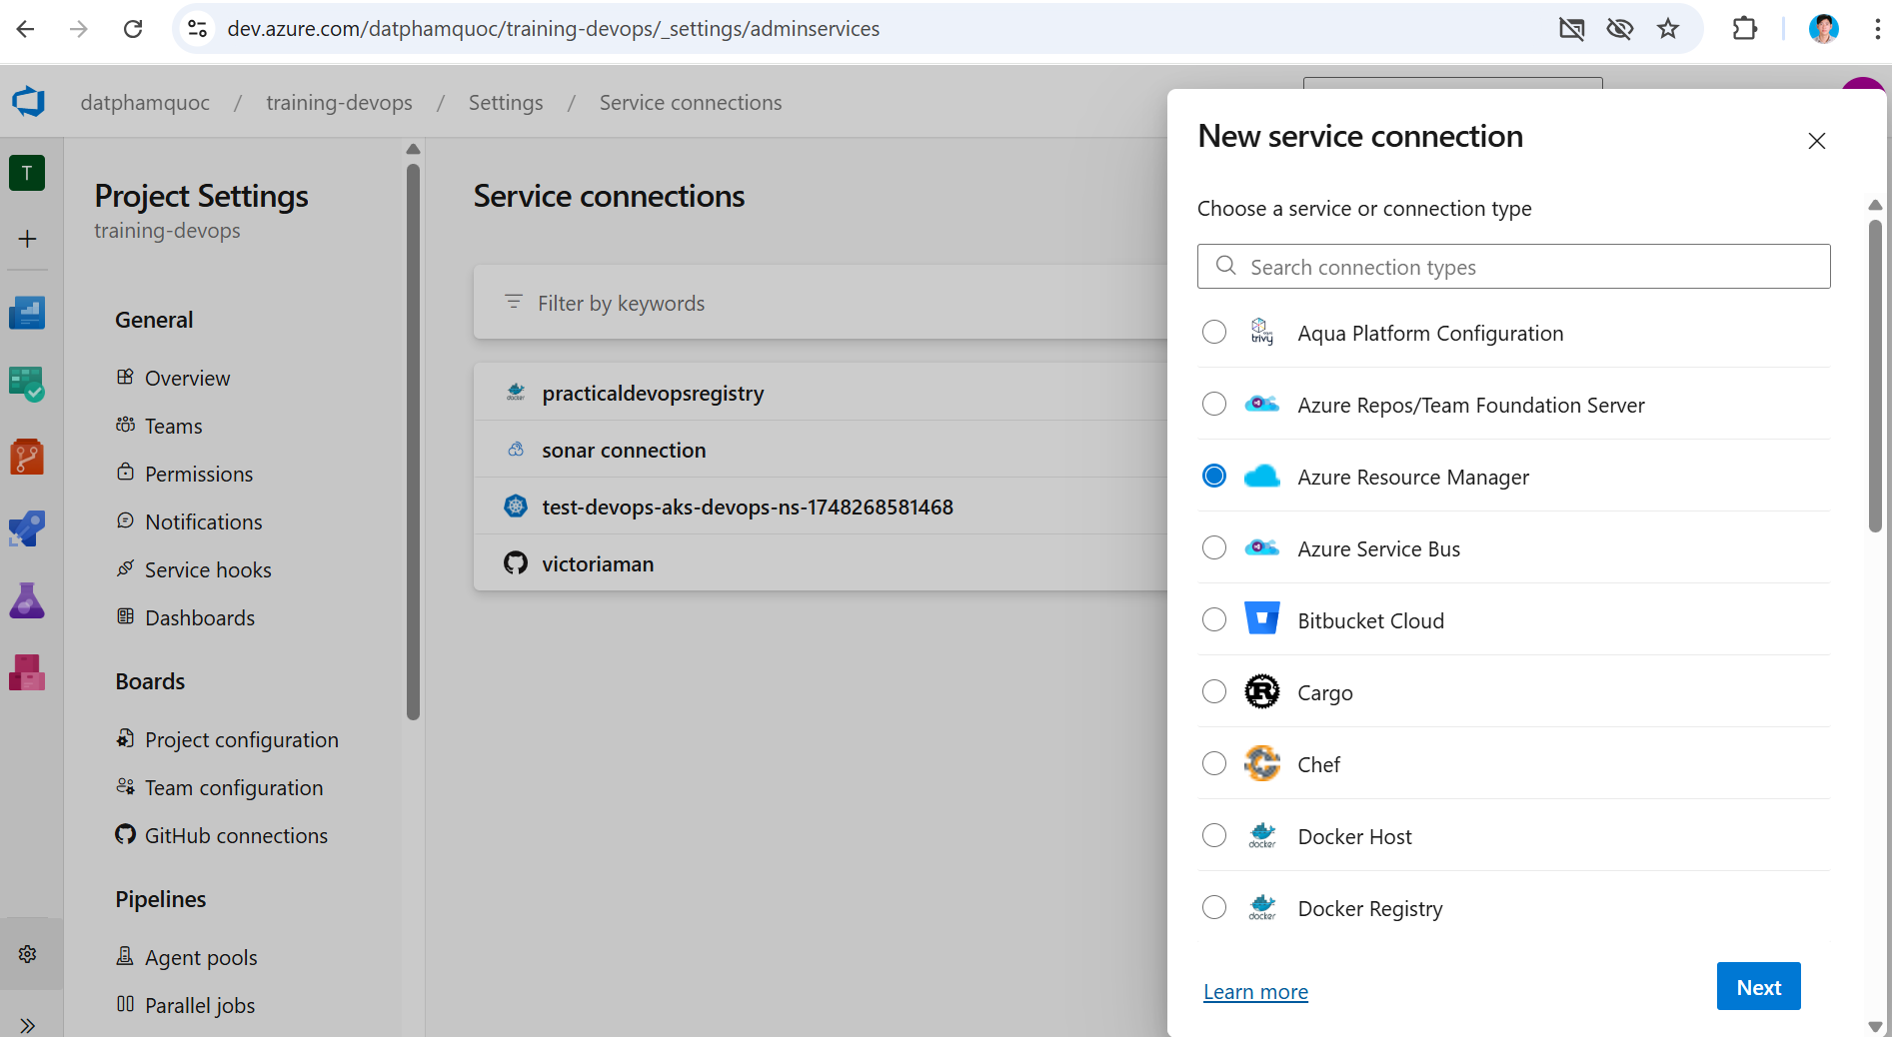

Input as below

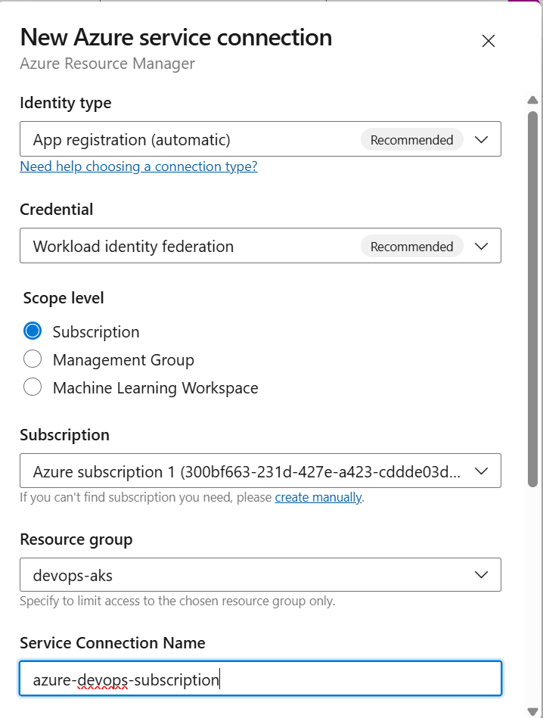

Click Save, new connection is created

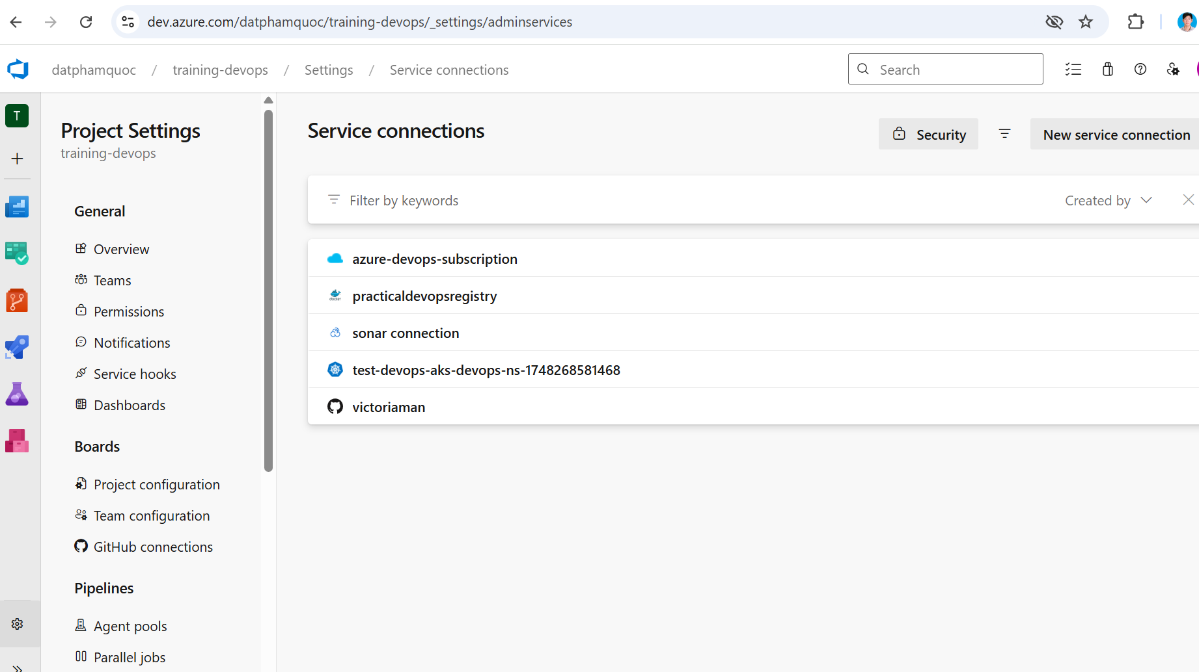

**Create pipeline**

# Click Pipelines menu => Create Pipeline

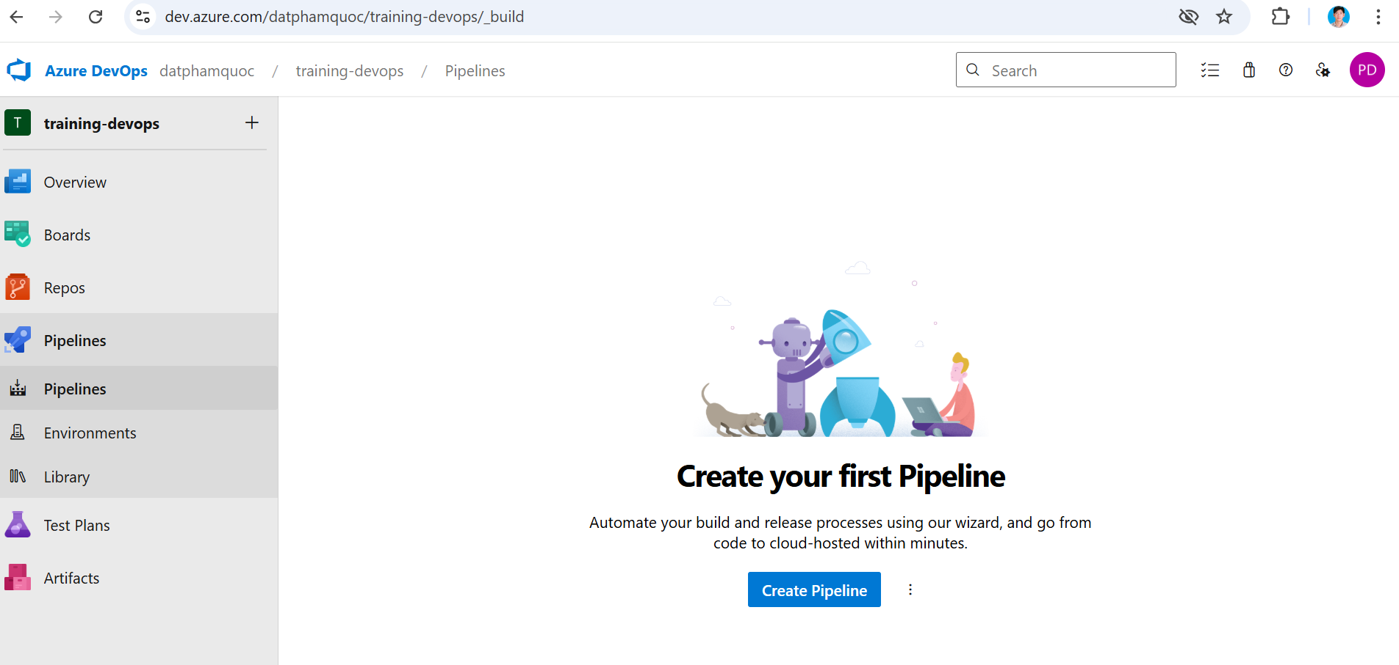

# Pick Github

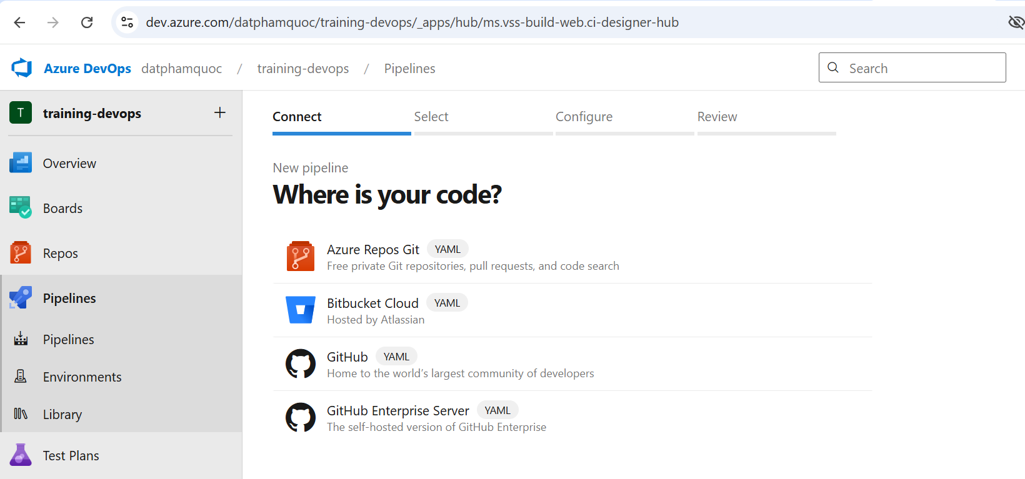

# Select sd3500_msa_frontend

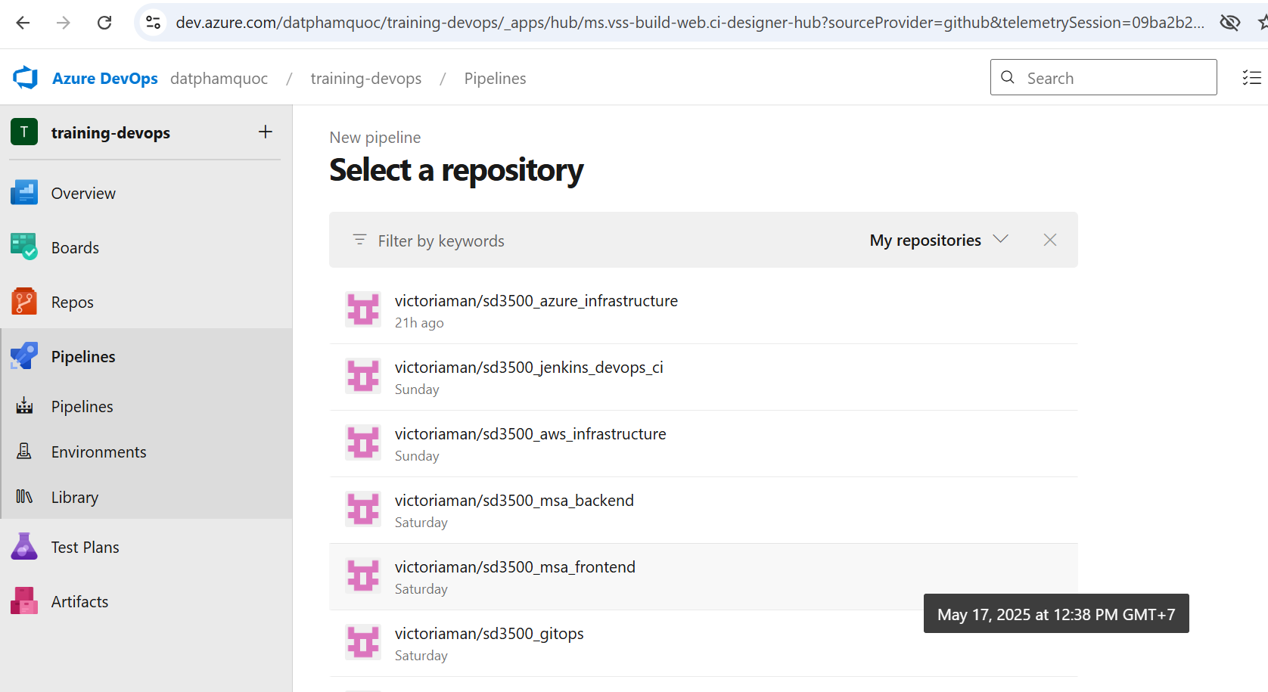

# Pick Docker (Build and push an image to Azure Container Registry)

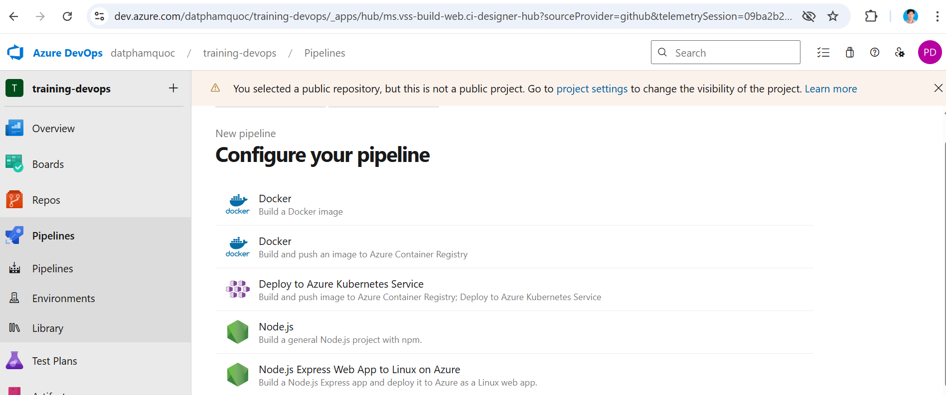

# Choose subscription -> Continue

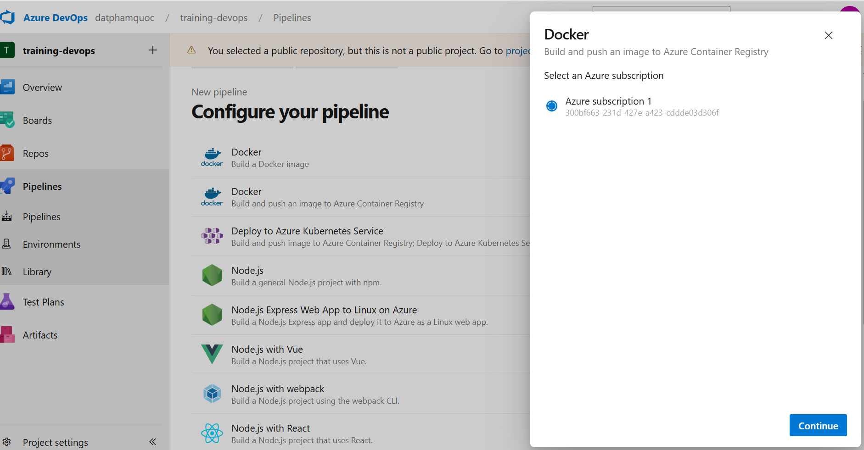

# Choose Container registry, image name and location of Dockerfile => Validate and configure

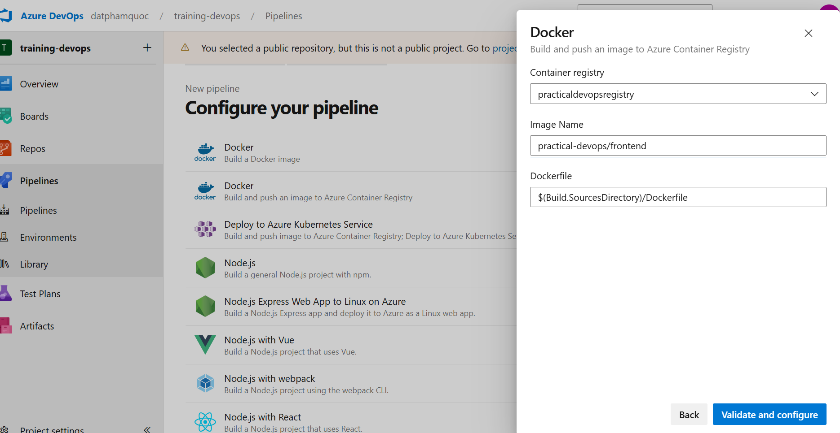

# Click Save to create azure-pipeline.yml (we will adjust this pipeline to add another step as trivy, Sonar scan)

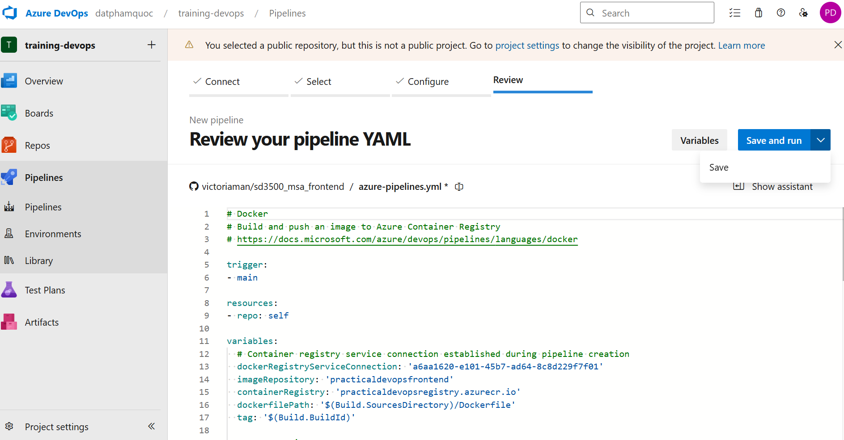

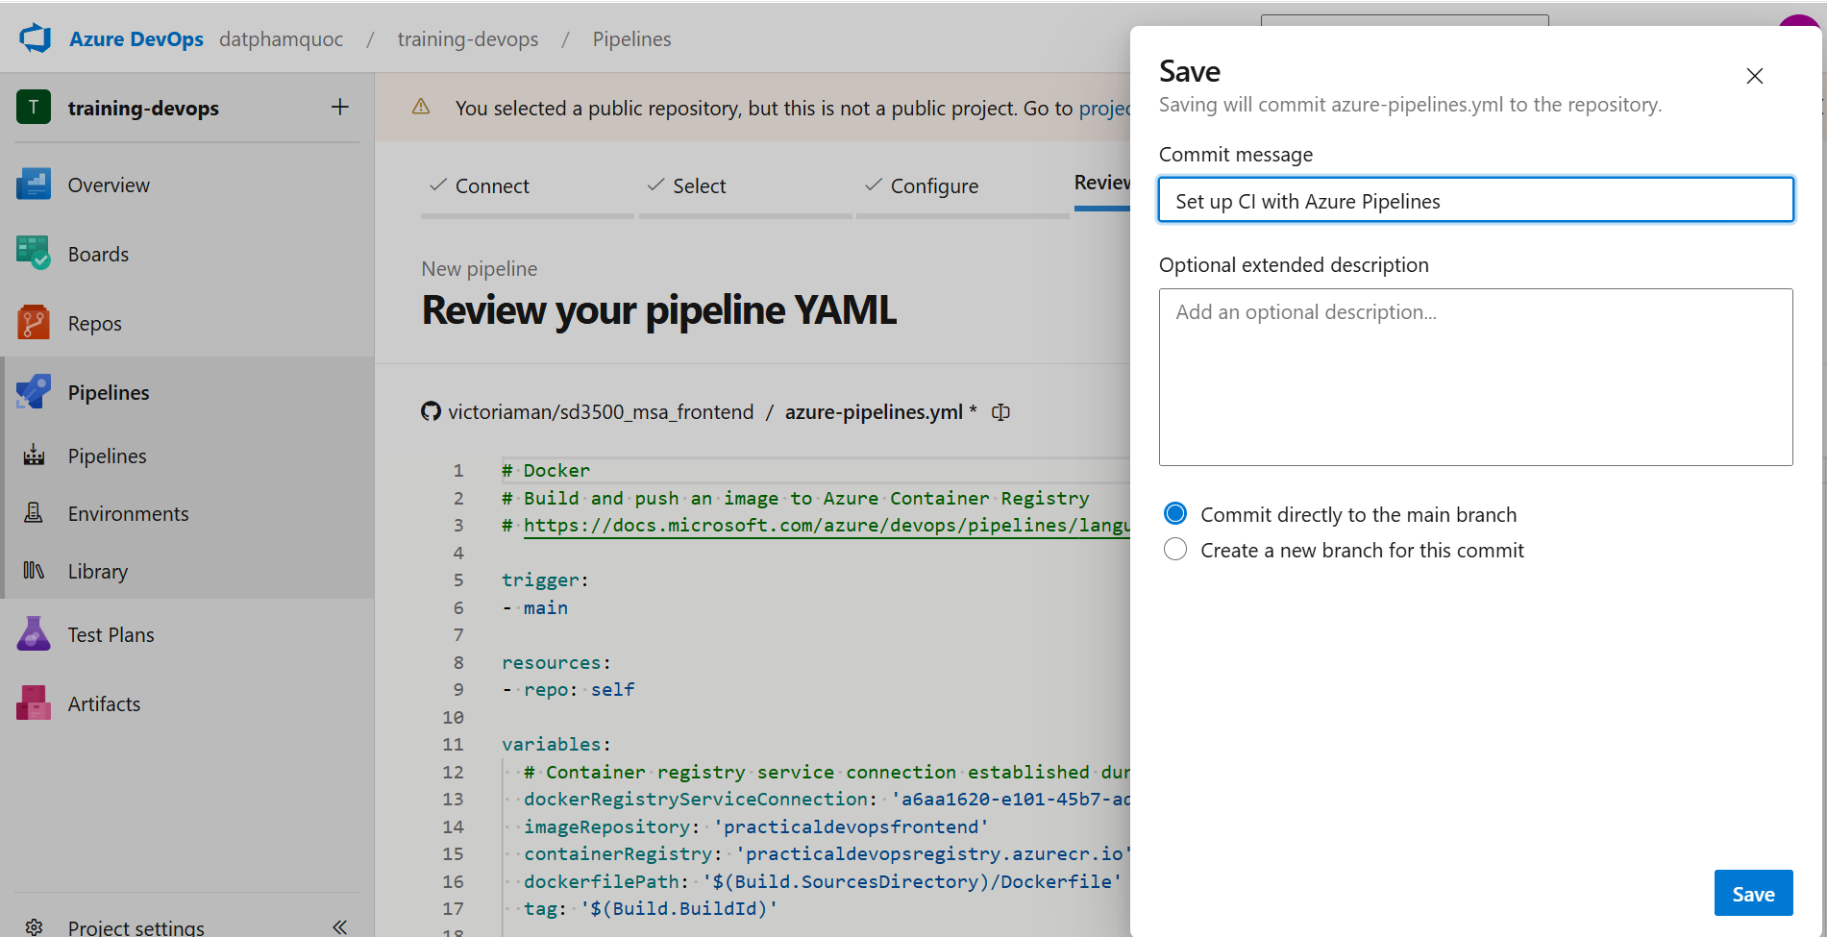

azure-pipelines.yml is generated in Github

